LEARNER WORKBOOK
FULL NAME & SURNAME

ID NUMBER:

NAME OF ASSESSOR

DATE OF ASSESSMENT

VENUE

MODEL ANSWERS
ACHIEVED |  | NOT ACHIEVED
KNOWLEDGE
SKILLS

Signature of learner Signature of Assessor
In terms of the Copyright Act 1978:

No part of this manual may be reproduced or translated in any form or by any means, electronic or mechanical including photocopying, recording or by an information storage and retrieval system without the express permission from TDA.

COPYRIGHT: TRAINING DYNAMICS AFRICA
First edition 2008

Publications disclaimer

Neither the authors nor the SETA can accept any responsibility for any legal or any other consequences, which may arise directly or indirectly as a result of the use or adaptation of or reliance upon any of the content of this material.

This material has been compiled based on the UNIT STANDARD 244189 CONDUCT ACCESS AND EGRESS CONTROL.

The program has been accredited by SASSETA in the Republic of South Africa.

Material compiled by: Training Dynamics Africa

HOW THIS LEARNER WORKBOOK IS COMPILED

This learner workbook has been compiled to equip learners with the necessary skill, knowledge and attributes that will enable them to man an access control point. They will also be able to execute access control duties in a manner that will contribute towards the safety of an organisation or environment.

A person credited with this unit standard will be able to:

- Explain access and egress control functions.
- Control people, vehicles and materials at an access and egress control point.
- Search people, goods and vehicles.
- Escort authorized persons and vehicles.

You have to study the content and guidelines given in your learner reference guide to complete this workbook.

Remember that this completed workbook must be handed in as it will form part of your formative assessment and will play a role in awarding you the required 07 credits that are to be achieved upon completion of this module.

Write neatly and legibly and ensure that you do not simply copy the information contained in the learner reference guide into your workbook. Give your own opinion and ideas where applicable and write the answers in your own words to indicate your level of understanding and learning.

Good luck with the completion of this workbook.

LEARNING UNIT 1

Access and Egress Control

LEARNING OUTCOMES

A learning credited with this unit will be able to:

- Define access control.
- Explain the purpose for access control.
- Explain the objectives of access control and egress control.
- Explain the meaning of outer layer protection.
- Identify and demonstrate knowledge and skills in the use of the various access control methods/aids.
- Identify and demonstrate knowledge and skills in the use of the various access control identification system.
- Explain the relation between access control measures and internal and external threats.
- Explain the role of access control in the event of an emergency.

LEARNER ACTIVITY 1 (page 13)

Explain the purpose of having access control and egress control functions at a building.
Just as every building has its own personality, each building also has its own unique movement control requirements. Failure to recognise this element of facility control can be not only expensive, but also disastrous. As security managers review the loss potential of their buildings, consideration must be given to the movement and control of people within its confines. An access and egress control system designed to complement the manufacturing procedures will go a long way towards reducing losses and making the other protective systems efficient and cost effective. Management directives and policies are designed to meet a variety of conditions. The access control system must show this same flexibility in order to provide predictable regulation and monitoring of the movement of people and access (Cherry 1986: 157).

Control of access to specific areas within a building is particularly important where the general public is admitted. Generally speaking, it is not necessary to install walls, partitions, doors or windows to the same high security specifications that apply at the perimeter of the building. Mechanical combination locks, or eloectrical locks operated by personal codes or access control cards and fitted to standard doors will normally suffice in maintaining a “need to be here” principle. One exception to this arises where the general public interfaces with employees who have direct access to substantial amounts of cash or valuables. In such cases there is an additional risk (Hearnden & Moore 1996:48).
Requirements achieved | YES |  | NO
Comments in support of decision
_______________________________________________________________________
_______________________________________________________________________
_______________________________________________________________________
_______________________________________________________________________
_______________________________________________________________________
_______________________________________________________________________
_______________________________________________________________________

LEARNER ACTIVITY 2 (page 14)

Explain the objectives of access control.
♦ | Permit or deny entry to or presence in a given place;
♦ | Increase or reduce the rate or density of movement to, from or within a defined place;
♦ | Protect persons, materials or information against unauthorised observation or removal; and
♦ | Prevent injury to people or damage to material (Auerb |  |  | ach 2003:187).
 | Requirements achieved | YES |  | NO
Comments in support of decision
_______________________________________________________________________
_______________________________________________________________________
_______________________________________________________________________
_______________________________________________________________________
_______________________________________________________________________
_______________________________________________________________________
_______________________________________________________________________

LEARNER ACTIVITY 3 (page 14)

Explain the objectives of egress control.
♦ | To ensure that company assets are not taken out of the premises without the necessary approval; and
♦ | It creates an additional layer of protection and acts as ployee theft, shoplifting etc. |  |  |  | a crime deterrent i.e. em-
 | Requirements achieved | YES |  | NO
Comments in support of decision
_______________________________________________________________________
_______________________________________________________________________
_______________________________________________________________________
_______________________________________________________________________
_______________________________________________________________________
_______________________________________________________________________
_______________________________________________________________________

LEARNER ACTIVITY 4 (page 15)

Provide a detail explanation of at least four outer layers of protection.

Demonstrate your understanding by providing three examples of each which can be found at your workplace.

Perimeter Barriers

According to Fay (2006:157) the security advantages of barriers are;

♦ To control the movement of people, vehicles into, out of, within the facility;
♦ Segregate or compartmentalize sensitive areas; and
♦ Provide physical protection to objects, materials, and processes of a critical nature.

Facility Security Controls (General)

Just as every building has its own personality, each building / facility has its own unique movement control requirements. Failure to recognise this element of facility control can not only be expensive, but also disastrous. As security managers review the loss potential of their buildings, consideration must be given to the movement and control of people within its confines.

Security Lighting

Illuminating a site or building perimeter will not delay an intruder, but an intelligently designed installation may increase the deterrent factor. If it is used in conjunction with CCTV good lighting will certainly assist in detecting unwelcome visitors. There are many factors to consider when planning a strategy for security lighting. Here are some of the most important;

Which areas need to be illuminated? The key areas for consideration are;

♦ The site boundary or perimeter including external car parks;
♦ The open areas between the perimeter and the building(s); ♦ Pedestrian and vehicle access points; and the
♦ Building interior.

Vehicle Control

Vehicle control should be precise and conform to the protection requirements of the facility. Vehicle movement monitoring is primarily designed to alert a dispatcher in shipping and receiving of the arrival or departure of a vehicle (Cherry 1986: 116).

Visitors Control

♦ Turnstile

It can also be made so as to enforce one-way traffic of people, and in addition, it can restrict passage to people who insert a coin, a ticket, a pass, or similar. Thus a turnstile can be used in the case of paid access (sometimes called a fare gate when used for this purpose), for example public transport as a ticket barrier or a pay toilet, or to restrict access to authorized people, for example in the lobby of an office building.

♦ Road Blockers

Road Blockers can be used to ensure that vehicles do not enter or leave your premises without your permission. With a wide variety of applications, road blockers can prove particularly useful on sites with limited access space.

♦ Bollards

Bollards have numerous uses. They can be used for ornamentacar-parking security, to reserve parking paces or to restrict accemanual (collapsible or telescopic) and hydraulic bollards that caa range of access control methods.

♦ Speed Ramps

Used to control the speed of flow of traffic, for example, on cons shopping centers etc.

♦ Boom gates

Suitable for commercial applications and for car parks where heavy duty open/close operations are required.

Requirements achieved | YES |  | NO
Comments in support of decision
_______________________________________________________________________
_______________________________________________________________________
_______________________________________________________________________
_______________________________________________________________________
_______________________________________________________________________
_______________________________________________________________________

LEARNER ACTIVITY 5 (page 26)

Explain three identification system that can be used to offer effective access and egress control.

Employee Badges (Cards) and Visitor Passes

A basic and time honoured access control tool is the employee identification card or badge. A workplace with few employees and low security needs may choose to rely on personal recognition as an alternative to the identification badge, but a workplace with more than a few employees will find the identification card useful. The control of visitors works differently. Visitor passes issued at an entry control point substitute for identification cards. Visitor passes are typical constructed of paper. The pass is dated and issued for a set period; usually one day is applied for at a reception or security desk, and requires the visitor to present a form of photo identification i.e. drivers licence, ID book etc.

A condition of issuance may be approval by an employee. In some situations only certain employees are allowed to approve visitor access, and the day and time of visit must be pre-arranged. In medium to high security situations, the visitor are escorted while inside the facility. In a safety sensitive workplace, a visitor may have to undergo a briefing, view a film, sign a release, and put on protective apparel such as a hard hat, safety glasses, and steel toed boots. There must be a record of the visit.

Identification Cards

♦ Hollerith: This very early form of access card has small holes that can be read by a light source or contact brushes. Today’s use of Hollerith cards is pretty much limited to hotel security. The guest slides the card into a slot above the door handle. The lock disengages when a reading of a card matches a guest’s registration at the lobby desk. This very simple technology is usually not suitable for higher level security.

♦ Magnetic stripe: This type of card has a data encoded stripe on one face. When the card is withdrawn from or swiped through a reader, the stripe passes over a magnetic head not unlike that of a tape player. The code on the stripe is compared to access criteria that were earlier entered into the system. Access criteria reflect the cardholder’s identity, the areas the cardholder is authorised to enter, and time frames for entry (normal operating hours, evening hours, weekends, holidays). Compared to other card types, the magnetic stripe cost less and can hold a large amount of data. However the magnetic stripe can wear out or become damaged over time, and the vinyl plastic construction of the card can lead to chipping and breaking.

♦ | Barium ferrite: This type of card is sometimes called a magnetic spot card or magnetic sandwich card. It is cut from three layer plastic stock. The middle layer or core is barium ferrite that has been magnetized with a pattern of dots arranged in a readable pattern. The pattern is code fixed by the magnetic polarity of the spots. The barium ferrite card is slightly more expensive than the magnetic stripe card. It is also subject to problems resulting from wear and tear, and is vulnerable to deciphering.
♦ | Bar code: This card bears on one side (usually the front) a series of lines forming a code readable by an optical scanner. The pattern of lines looks very much like the pattern of lines found on the outside of supermarket items. Because a bar code is easy to duplicate, it is not suitable for good security practice.
♦ | Wiegand: The Wiegand card is also called an embedded wire card. The technology is based on the Wiegand effect, a phenomenon observed when specially prepared ferromagnetic wires suddenly reverse themselves upon exposure to an external magnetic field. Wires inside the Wiegand card are formed in a permanently tensioned helic twist. The order and the spacing of the wires establish a unique code for each card. The magnetic reversals in the wires are converted into distinct, consistant electrical pulses that are read and processed. The card’s thickness and composition of stock make it resistant to pocket damage. It is, however, susceptible to malfunction arising from wear after many passes through reader slots.
♦ | Proximity: The proximity card has an embedded microcircuit that emits frequencies detectable by a reader. The reader reacts to frequencies when the card is placed in close proximity. Sturdy composition makes the card resistant to tampering and interfering effects of weather and shock. Two other features of the card make it attractive. The emitted frequencies are sufficiently powerful for the reader to be concealed behind a thin wall or mounted inconspicuously (possibly for aesthetic reasons), and the card can work through clothing or a handbag.
♦ | Smart Card: Regarded as the card of the future, the smart card contains its own processor, making it capable of running its own internal programs. The very large amount of data that can be contained in a smart card allows it to serve purposes that go beyond access control. For example, the cardholder’s medical history can be stored for quick retrieval in medical emergency and cashless purchases is recorded. The downside of the smart card is cost. On the other hand it offers several advantages; the card is durable and tamper resistant, counterfeiting and duplication are difficult, encryption presents an obstacle to compromising the code, the card can be programmed to expire on a certain date, and smart card technology is suitable for many applications (Fay 2006: 178-180).
 | Requirements achieved | YES |  | NO
Comments in support of decision
_______________________________________________________________________

LEARNER ACTIVITY 6 (page 38)

Discuss the role of access control officers during an emergency situation.
Specific site access control procedures should clarify the following with regard to emergency situations;

Access control procedures should clearly state who should be allowed in the Emergency Control Centre.

♦ Medical Emergencies: Access should be controlled at medical scenes to ensure that the paramedics can perform their duties without interference from bystanders.

♦ Fire Emergencies During a fire emergency access to buildings needs to be controlled and limited to fire teams and the fire department on arrival.

♦ Armed Robbery: When an armed robbery or any other crimes are committed, access to the scene should be limited to ensure that the crime scene is not contaminated. The crime scene should be secured and only the police should be allowed on the crime scene.

♦ Assembly Areas: Access and egress needs to be controlled at assembly points to ensure that all persons can be accounted for during an emergency.

♦ Suspicious Mail and Packages: If a suspicious mail or package is found inside a premises / building access should be limited to the area until the police declare the area safe.

♦ Explosions: When an explosion occur at a building premises (criminal / non criminal) only emergency teams (only if there are injuries) and emergency personnel, EMS, Fire Brigade and SAPS should be allowed on the scene.

♦ Chemical Spills: Access to areas where chemical spills occurred should be limited to health and safety specialists.

♦ Re-Entry of Evacuated Buildings: Access to buildings should only be allowed once a directive is received for the client or emergency personnel. _______________________________________________________________________
_______________________________________________________________________
_______________________________________________________________________
_______________________________________________________________________
_______________________________________________________________________
_______________________________________________________________________
_______________________________________________________________________
_______________________________________________________________________
_______________________________________________________________________
_______________________________________________________________________

Requirements achieved | YES |  | NO
Comments in support of decision
_______________________________________________________________________
_______________________________________________________________________
_______________________________________________________________________
_______________________________________________________________________
_______________________________________________________________________
_______________________________________________________________________ SELF-ASSESSMENT

The learner must make use of the following self-evaluation checklist to rate himself against the learning outcomes of this particular training module in establishing the level of mastery of the information.

- Not able to comply

- Reasonable compliance (Not acceptable for final evaluation)

- Able to comply fully
 | LEARNING OUTCOMES | 1 | 2 | 3
1 | Define access control.
2 | Explain the purpose for access control.
3 | Explain the objectives of access control and egress control.
4 | Explain the meaning of outer layer protection.
5 | Identify and demonstrate knowledge and skills in the use of the various access control methods/aids.
6 | Identify and demonstrate knowledge and skills in the use of the various access control identification system.
7 | Explain the relation between access control measures and internal and external threats.
8 | Explain the role of access control in the event of an emergency.

_____________________________________ ________________________ Evidence Collector Signature Date

_____________________________________ ________________________
Security Officer Signature Date

LEARNING UNIT 2

Operating and maintaining access and egress sites.

LEARNING OUTCOMES

A learning credited with this unit will be able to:

- Operate and maintain an access/egress control site in accordance with the relevant legal requirements and workplace procedures.
- Conduct access/egress control of people vehicles and goods per workplace procedure.
- Operate site-specific equipment in accordance with workplace procedures and manufacturer’s specifications.
- Deal with unauthorized/authorized people, vehicles and goods as per workplace procedure and relevant legal requirements.
- Handle emergencies and irregularities according to workplace procedures and contingency plans.
- Ensure appropriate interpersonal skills for effective customer relationships.

LEARNER ACTIVITY 1 (page 43)

As an access control security officer, it is expected of you to control all access and egress to the security area you are protecting. What are the five main aspects to be controlled during access and egress control?
To perform their duty effectively, it is of the outmost importance that the security officer understands all task and functions. The work procedures may differ from site to site, depending on the type and extent of the property to be guarded. There are five aspects to be controlled during access and egress control:

♦ Employees
♦ Visitors
♦ Contractors
♦ Vehicles
♦ Goods
Requirements achieved | YES |  | NO
Comments in support of decision
_______________________________________________________________________
_______________________________________________________________________
_______________________________________________________________________
_______________________________________________________________________
_______________________________________________________________________
_______________________________________________________________________
_______________________________________________________________________

LEARNER ACTIVITY 2 (page 43)

Work procedures for access and egress control must indicate the following:
Work procedures for access and egress control must identify the following:

♦ Who has access and to which area.
♦ | Access and egress procedures.
♦ | Identification procedures.
♦ | Monitoring of people, vehicles and goods during a period of duty/visit.
♦ |  |  | Site instructions and regulations to be applied during access and egress control.
 | Requirements achieved | YES |  | NO
Comments in support of decision
_______________________________________________________________________
_______________________________________________________________________
_______________________________________________________________________
_______________________________________________________________________
_______________________________________________________________________
_______________________________________________________________________
_______________________________________________________________________

LEARNER ACTIVITY 3 (page 43)

Your security manager approaches you to assist him in thinking of the current and additional measures that can be taken within your access control. There are five possible measures that can be taken. Name the five and give a short description of each.
Work procedures for access and egress control must identify the following:

♦ Who has access and to which area.
♦ Access and egress procedures.
♦ Identification procedures.
♦ Monitoring of people, vehicles and goods during a period of duty/visit.
♦ Site instructions and regulations to be applied during access and egress control.
Requirements achieved | YES |  | NO
Comments in support of decision
_______________________________________________________________________
_______________________________________________________________________
_______________________________________________________________________
_______________________________________________________________________
_______________________________________________________________________
_______________________________________________________________________
_______________________________________________________________________

LEARNER ACTIVITY 4 (page 55)

Demonstrate your understanding of zoning by draw a picture of a typical floor plan of a building.

Indicate your understanding of zoning on the floor plan.

A system of controlling movement and access of personnel and visitors is essential. This enables the security officer to monitor and control the access to and movement within the different parts of the premises. This prevents or makes it much more difficult for unauthorized persons to enter unauthorized areas. Different companies will have different ways of setting up and running a system to monitor and control employee and visitor movement, but the general principles are as follows:

Determine the various working areas within the company, e.g.

♦ Receiving area (AA),
♦ Production area (BB),
♦ Engineering area (CC),
♦ Planning area (DD),
♦ Administration area (EE), etc
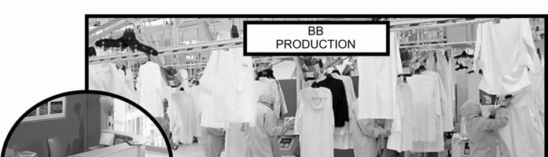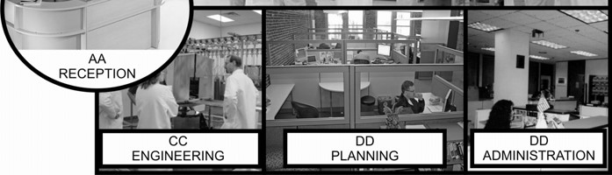
_______________________________________________________________________
_______________________________________________________________________
_______________________________________________________________________
_______________________________________________________________________
_______________________________________________________________________
_______________________________________________________________________
_______________________________________________________________________
_______________________________________________________________________
_______________________________________________________________________
_______________________________________________________________________

Requirements achieved | YES |  | NO
Comments in support of decision
_______________________________________________________________________
_______________________________________________________________________
_______________________________________________________________________
_______________________________________________________________________
_______________________________________________________________________
_______________________________________________________________________

LEARNER ACTIVITY 5

Complete the attached registers. The assessor will provide you with handouts which consist of valuable information to be used
Requirements achieved | YES |  | NO
Comments in support of decision
_______________________________________________________________________
_______________________________________________________________________
_______________________________________________________________________
_______________________________________________________________________
_______________________________________________________________________
_______________________________________________________________________

I hereby grant permission for an
Authorised officer of ………
to inspect the contents of my v
ehicle or any container I may
have in my possession whilst I am on a site occupied by ……….
Date
Name of visitor/
contractor
Company
Tel:
Who is
being
visited
Vehicle
Register
Per. no
Time
in
Time
out
ID NO.
Hand
Sign

NUMBER: 00049
VISITORS REGISTER

KEY CONTROL REGISTER | Page  of  pages | Received By
KEY CONTROL REGISTER | Page  of  pages | Date Re-  turned
KEY CONTROL REGISTER | Page  of  pages | Issued To:
KEY CONTROL REGISTER | ACTIVITY:
KEY CONTROL REGISTER | ACTIVITY: | Issued  By
KEY CONTROL REGISTER | ACTIVITY: | Date Issued
KEY CONTROL REGISTER | ACTIVITY: | No. of Keys  Issued
KEY CONTROL REGISTER | ACTIVITY: | Location
KEY CONTROL REGISTER | ACTIVITY: | Key Code  Number

LEARNER ACTIVITY 6

Explain a typical access control site procedure that can be found at your workplace.
_______________________________________________________________________
_______________________________________________________________________
_______________________________________________________________________
_______________________________________________________________________
_______________________________________________________________________
_______________________________________________________________________
_______________________________________________________________________
_______________________________________________________________________
_______________________________________________________________________
_______________________________________________________________________
_______________________________________________________________________
_______________________________________________________________________
_______________________________________________________________________
_______________________________________________________________________
_______________________________________________________________________
_______________________________________________________________________
_______________________________________________________________________
_______________________________________________________________________

_______________________________________________________________________
_______________________________________________________________________
_______________________________________________________________________
_______________________________________________________________________
_______________________________________________________________________
_______________________________________________________________________
_______________________________________________________________________

Requirements achieved | YES |  | NO
Comments in support of decision
_______________________________________________________________________
_______________________________________________________________________
_______________________________________________________________________
_______________________________________________________________________
_______________________________________________________________________
_______________________________________________________________________

LEARNER ACTIVITY 7 (page 57)

Entry and exit to premises are usually controlled by an access and egress control system. The functions of such a control system could include the following:
Entry and exit to premises is usually controlled by an access and egress control system.

The functions of such a control system could include the following:

♦ Supervision of access and/or egress of regular employees.
♦ Control of visitors and contractors.
♦ Control of delivering or dispatching of goods.
♦ Conducting of authorized searches.
♦ Supervision of access or egress of all vehicles, including the searching of such vehicles.
♦ Escorting persons or vehicles in high risk areas.
♦ Keeping record of the above.

The work procedures for access and egress control systems can vary from area to area and be more specific depending on the security risk of the premises.

Persons and vehicles can be grouped into the following (zoning):

♦ Permanent staff that work in a specific area.
♦ Contractors, repair and maintenance staff who are required to work in any area to carry out their tasks.
♦ Security personnel who are required to supervise specific security operations.
♦ Vehicles delivering goods (these can vary from a simple parcel to petrol or explosives).
♦ Vehicles collecting garbage or scrap.
♦ Company vehicles delivering or loading the core product.

The best way of identifying persons is by an identification card system (visibly displayed on the individual).

♦ This identification card system couples to a list of persons authorized for access provides further confirmation. The list must be current. ♦ Electro-magnetic card systems must be based on the card-key principle. ♦ Visitors and contractors must give their name and purpose of visit to the access control security officer. This information should be checked against some form of identification e.g. ID book or passport.
♦ The visitor must be checked with the person being visited and if approved, the visitor’s particulars must be recorded in a visitor’s register. A visitor’s card must be given to the person and then he or she must be escorted to the office of the person visited. Once the visit is over, the visitor must be escorted back to the egress point. _______________________________________________________________________
_______________________________________________________________________
_______________________________________________________________________
_______________________________________________________________________
_______________________________________________________________________
_______________________________________________________________________
_______________________________________________________________________

Requirements achieved | YES |  | NO
Comments in support of decision
_______________________________________________________________________
_______________________________________________________________________
_______________________________________________________________________
_______________________________________________________________________
_______________________________________________________________________
_______________________________________________________________________

LEARNER ACTIVITY 8 (page 73)

To control unauthorized and authorized people, vehicles and goods at an access control point, the following guidelines will make it difficult for unwanted persons to gain access to premises:
To control unauthorized and authorized people, vehicles and goods at an access control point, the following guidelines will make it difficult for unwanted persons to gain access to premises:

Visitors

♦ Have a special visitors parking and issue them with a temporary parking permit (to be returned when they leave).
♦ Identify particular entrances and exits for use by visitors. These entrances should be security controlled.
♦ Keep a visitor’s register with the following visitor particulars:

⇒ Name and surname,
⇒ Firm or company represented,
⇒ Reason for visit, ⇒ Time in and out,
⇒ Confirmation of appointment (the person visited),
⇒ Permit (number) issued before entering and collected before departure.

♦ All visitors must be escorted when entering a restricted area. Make use of a security officer or make the person being visited responsible.

Vehicles

♦ A permit system should also be in place for authorised vehicles.
♦ The vehicles should be checked prior to entry and before leaving a restricted area. ♦ Delivery vehicles should be provided for by means of a special permit or detachable sticker and should also be checked on arrival and before departing.

Goods

Almost all companies are faced with the risk of losing products, goods, equipment, etc. Some companies also run the risk of employees or visitors entering the premises with unauthorized goods, which are not allowed for various reasons. _______________________________________________________________________
_______________________________________________________________________
_______________________________________________________________________
_______________________________________________________________________
_______________________________________________________________________
_______________________________________________________________________
_______________________________________________________________________

Requirements achieved | YES |  | NO
Comments in support of decision
_______________________________________________________________________
_______________________________________________________________________
_______________________________________________________________________
_______________________________________________________________________
_______________________________________________________________________
_______________________________________________________________________

LEARNER ACTIVITY 9 ()page 61)

Vehicle control is achieved by…….
Vehicle control is achieved by:  ♦ Booms, e.g. office premises, shopping centres, housin nikons, etc. |  |  |  | g estates, universities, tech-
♦ | Buffer equipment, e.g. roadblocks or areas where vehicles are prohibited such as at sporting events, accidents etc.
♦ | Inspection pits, e.g. entrances at highly secured areas, weigh bills, airports.
♦ | Dogs, e.g. to sniff out explosives, drugs or smuggled goods.
♦ | Personnel with mirrors, e.g. to look underneath vehicle unauthorized parcels, smuggled equipment, or stolen |  |  | property. | s for explosives,
 | Requirements achieved | YES |  | NO
Comments in support of decision
_______________________________________________________________________
_______________________________________________________________________
_______________________________________________________________________
_______________________________________________________________________
_______________________________________________________________________
_______________________________________________________________________
_______________________________________________________________________

LEARNER ACTIVITY 10 (page 61)

Why is observation important for the success of a security officer doing duty at an access and egress control site.
Observation contains a distinct mental image of what is seen, with the definite realisation that he total image consists of detail and knowledge that this total image is related to reality. As an example, we observe a medicine bottle. The total image is the medicine bottle.

The knowledge that the total image consists of detail necessitates the analysis of the contents, the label, possible fingerprints, etc. whilst the knowledge that the total image is related to reality directs our thoughts to the possibility of a case of poisoning or the smuggling of drugs. In this manner nothing is lost and we practise seeing facts in their true perspective.

The ability to identify and recall a situation accurately, completely and distinctly is effective observation.

The ability to observe is based on heritage, experience and education. The danger exists in relying on heritage and experience to observe a situation. The interpretation of the incident may subjectively be influenced, as the person uses himself as a measure of evaluation.
Requirements achieved | YES |  | NO
Comments in support of decision
_______________________________________________________________________
_______________________________________________________________________
_______________________________________________________________________
_______________________________________________________________________
_______________________________________________________________________
_______________________________________________________________________
_______________________________________________________________________

LEARNER ACTIVITY 11(page 63)

How should a security officer perform observation.
Observation should be tackled systematically

♦ Get a complete picture of the situation itself.

♦ | Work in straight line or circles.
♦ | Afterwards, attention must be given to independent, bigger objects in order to see what their relation to the whole may be.
♦ | Each object must be studied independently to ascertain how it fits into the picture.
♦ | The next step is to look at, feel, dissect and do everything possible to the object and any part thereof in order to observe the object and everything related thereto.
♦ | Lastly, and the most important, is to write down or imprint on the mind every particle and relation of the fact.
♦ | Observation without the ability interpret and represent facts clearly, completely and objectively would be of no value. Accurate description, therefore, means to differentiate between that which has actually been observed or seen. Conclusion are to be reported separately with regards to facts and deductions.
 | Requirements achieved | YES |  | NO
Comments in support of decision
_______________________________________________________________________
_______________________________________________________________________
_______________________________________________________________________
_______________________________________________________________________
_______________________________________________________________________
_______________________________________________________________________
_______________________________________________________________________

LEARNER ACTIVITY 12

Study picture below and answer the relevant questions
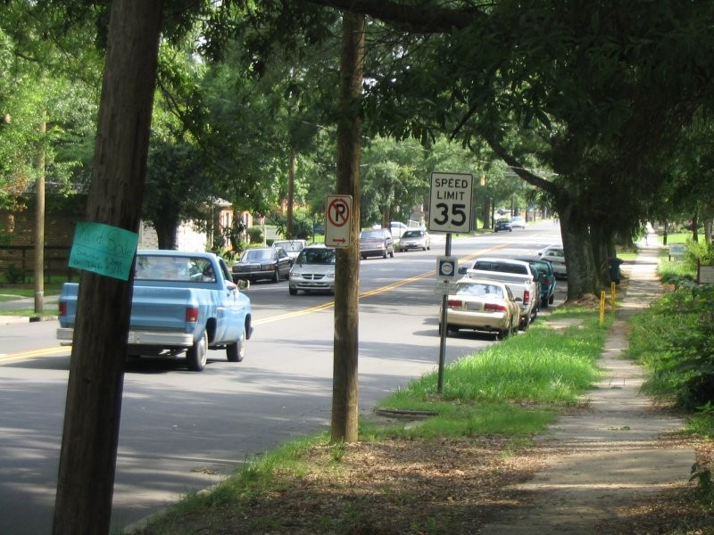
P 1
♦ Observe the picture for exactly 30 seconds. Look at everything you think might be important.
♦ After 30 seconds, answer the questions on the next page on a sheet of paper. (Do not read the questions before you look at the picture!)
♦ Are there cars parked on the sides of the road?
♦ What color is the pickup truck driving in the road?
♦ Any minivans around?
♦ What does the blue sign say?
♦ What's the speed limit?
♦ Are there any pedestrians on the road?
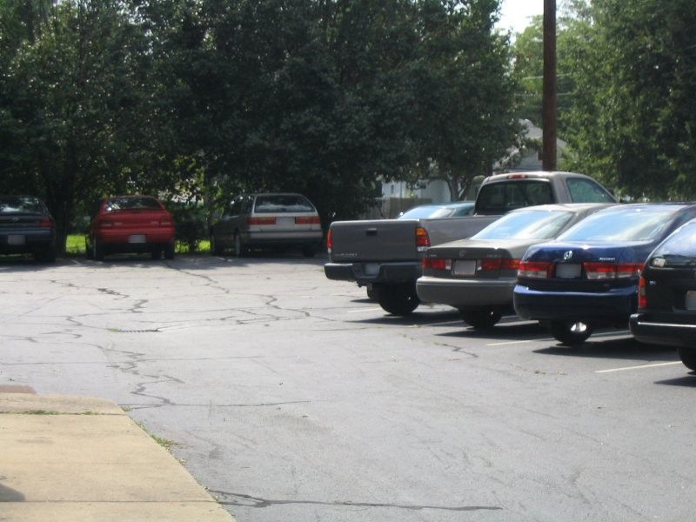
P 2
♦ Choose several people to be observers and choose two people to be investigators.
♦ Allow the observers to look at the picture for 30 seconds. The investigators should not look at the picture.
♦ After 30 seconds, the investigators should begin questioning the observers.
♦ Each Investigator should question each observer. Then, the Investigators should attempt to reconstruct the scene based on the "eyewitness testimony".
Investigators can use these questions to guide their inquiry, but may also think of their own questions.

♦ About how many cars can you see?
♦ Can you describe some of the cars in the lot?
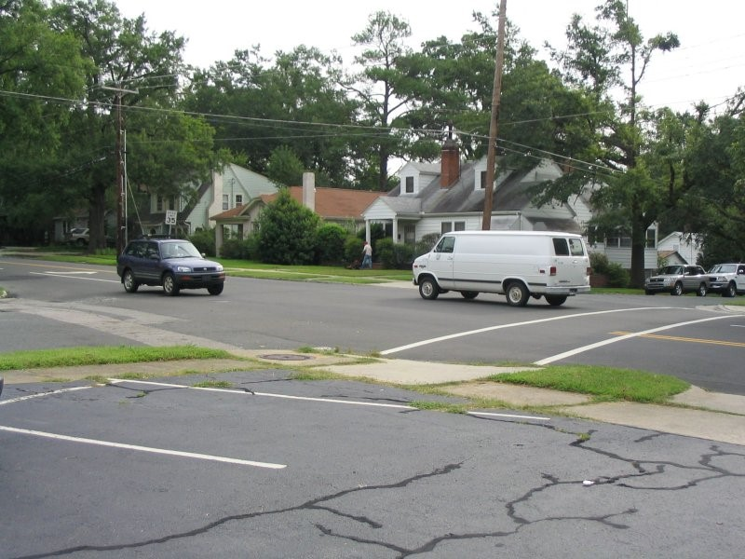
P 3
Investigators can use these questions to guide their inquiry, but may also think of their own questions.

♦ About how many cars can you see?
♦ Can you describe some of the cars in the lot?
♦ How many cars were in the intersection?
♦ Across the street, are there any parked cars on the side?
♦ Can you describe at least one of the cars driving through the intersection? ♦ Are there any other potential witnesses?

If they answer yes, ask the following question:

♦ What was this witness doing?
♦ Where was he? They should have noticed a person mowing a lawn across the street.
♦ What was the speed limit? 35
♦ Was there anyone parked in the first parking spot? No
People
Features
Build
Race
Age
Gender
Hair
height
Vehicles
Feature
Make
Model
Registration Nr
Colour
Year of manufacturer
Description
Objects
Feature
Description
Peculiar features
Condition

Requirements achieved | YES |  | NO
Comments in support of decision
_______________________________________________________________________
_______________________________________________________________________
_______________________________________________________________________
_______________________________________________________________________
_______________________________________________________________________
_______________________________________________________________________
_______________________________________________________________________

LEARNER ACTIVITY 13

CASE STUDY: Read the case study below and record the situation on the attached documentation.

♦ OB

Obtain all the necessary information from the case study below. The documentation needs to be complete and contain all the necessary and correct information as outlined in the case study.

The sound of thunder and bright flashes in the sky may have been a wonderful spectacle last night, but what I didn’t realize was that it would cause one of the worst days of my life. I did not know about the power failure at three this morning because I was fast asleep. The first time I realized that my alarm did not go off, was at ¼ past five this morning – which meant that I was going to be late for work. I rushed while getting dressed and did not have time to iron my uniform because I had to run to get the last taxi. In my haste I forgot to put my pocket book in my pocket, and I could not find my shoes, so I wore takkies instead.

I actually made it to work, only 7 minutes late. My co-worker that had just finished night shift was not very impressed with me because he still had to do the handover. He was going to miss his taxi and would have to wait at least ½ hour for the next one. Because I felt guilty about coming late, I told him to go – I would read the OB to get the details of the night shift….

It looked like things were eventually settling down to a normal, boring working day. Cars stop, “morning sir”, “who are you visiting sir”, “that would be at block C – second building on the left”, “have a nice day sir”. The same thing, over and over. Sometimes I feel like a tape recorder. Cars come, cars go.

In the mean time I’m still a bit unsettled from all the rushing around this morning and tired from lack of sleep because I had to settle the kids down who were crying because they’re scared of the thunder and lightning.

Then the blue BMW stops at the gate about 09:20 . He hoots. So I wasn’t quite as observant as I am supposed to be – I am tired, you know. I paste my smile on my face and walk up to the driver’s window.

I get as far as saying: “Good morning, Sir.”

“Good? – good???; so what’s good about it?”

“Where is Mr. Brown? It’s ten past nine. These $%# taxis! They caused an accident that has made me late! Open this #%^ boom!
“Sir”, I say, “I have to search your vehicle before you enter.” And I think to myself that this guy is so rude - I haven’t done anything to him!

“Never mind about my boot, open this gate, you $|%&*@& “%&*(%$(*%$*%)@*”

By now I’m getting very upset. Who does he think he is to swear at me and call me names? I’ll show him….

“Sir, please get out of your vehicle and open the boot. I will not let you pass until I have searched your vehicle!” I tell him.

“Yes, you *%(%^(%#*% - I’ll get out” - he swears at me again. Now he’s done it. There’s no way that someone insults my mother like that and gets away with it. I will search every inch of his car, and today is the day that he will not pass my boom.

He gets out of the car, and that’s the last thing I remember before I see my supervisor’s face and feel him shaking me. I am lying on the ground, and the boom is pointing up into the sky with blue BMW paint all over it. My jaw hurts like hell…

Occurrence book entry
Dag en datum:
Day of week and date: 15 May 2008
 |  | AARD VAN VOORVAL/NATURE OF OCCURRENCE
VOLG Nr. SERIAL No. | TYD TIME
123 | 09:10 | Patrol back: During the routine patrol it was discovered that a housebreaking and theft occurred at the computer lab. The housebreaking and theft was reported to Mr.  Maseko the security manager on duty.
 |  | Mr. Maseko determined that a Mecer laptop was stolen (asset number 4342222) The incident was reported to the SAPS.
 |  | The SAPS Reference number is SAPS S/Side 123/08/2005. The investigation officer is inspector Botha(012) 321 4333.,
 |  | Signed: J Ramoba
You are escorting Me Sithole from the control room to Mr Bembe the Financial Director of the company on 20 July 2006 at 14:00. You arrived at 14:30 at Mr Bembe’s office. On the way Mr Sithole complains about walking all the way to Mr Bembe. Use the information in the case study to make an entry in your ‘pocket book’.

Pocket book entry
2007/05/15  06:00 | Housebreaking and Theft Report: On 2007/05/15 at 069:00 during a routine patrol I discovered a housebreaking and theft at the computer lab of Building BB. No suspects or witnesses could have been identified. I secured the crime scene and no one was allowed to enter the scene.
I reported the matter to Mr Maseko my security manager, and the SAPS investigated the crime scene. SR Reference Number 13/08/2005 and OB Reference Number 123/05/2007.

Signed: J Ramoba

LEARNER ACTIVITY 14 (page 74)

How should a security officer deal with a member of the public.
Often the security officer is the first person seen when entering a company’s premise, If the visitor see’s the security personnel in a sloppy, dirt and incomplete uniform, then the first impression of the company and security officer will be poor. This poor impression will be further reinforced if the security officer lacks professionalism, cannot communicate effectively and demonstrates bad manners. On the other hand, a favourable impression will be created if the security officer:

♦ BE SMARTLY DRESSED: Make sure your uniform is clean and complete.

♦ ACT PROFESSIONALLY: Know your job and responsibility.

♦ COMMUNICATE EFFECTIVELY: Greet the person, Be friendly at all times, Be
helpful

♦ SHOWS CONCERN: Show your concern regarding their safety.

♦ DEMONSTRATE GOOD MANNERS: All security personnel own it to themselves to be proud of what they do. This pride can be shown in their personal appearance, in their enthusiasm for performing their alignments, and is a sense of accomplishment for a job well done. If a positive attitude prevails within the security department, it will carry over to all those who come into contact with them.
Requirements achieved | YES |  | NO
Comments in support of decision
_______________________________________________________________________
_______________________________________________________________________
_______________________________________________________________________
_______________________________________________________________________
_______________________________________________________________________
_______________________________________________________________________
_______________________________________________________________________ SELF-ASSESSMENT

The learner must make use of the following self-evaluation checklist to rate himself against the learning outcomes of this particular training module in establishing the level of mastery of the information.

- Not able to comply

- Reasonable compliance (Not acceptable for final evaluation)

- Able to comply fully
 | LEARNING OUTCOMES | 1 | 2 | 3
1 | Operate and maintain an access/egress control site in accordance with the relevant legal requirements and workplace procedures.
2 | Conduct access/egress control o people, vehicles and goods per workplace procedures.
3 | Operate site-specific equipment in accordance with workplace procedures and manufacturer’s specifications.
4 | Deal with unauthorized/authorized people, vehicles and goods as per workplace procedures and relevant legal requirements.
5 | Handle emergencies and irregularities according to workplac3e procedures and contingency plans.
6 | Ensure appropriate interpersonal skills for effective customer relationships.

_____________________________________ ________________________ Evidence Collector Signature Date

_____________________________________ ________________________
Security Officer Signature Date

LEARNING UNIT 3

Legal compliance

LEARNING OUTCOMES

A learning credited with this unit will be able to:

1. Understand the relevant legislation, policies and regulations required for lawful searching, detention and/or seizure of people, vehicles and goods.

LEARNER ACTIVITY 1 (page 79)

What are the articles that can be seized from an arrestee after an arrest has been made according to Article 20 of the Criminal Procedures Act 51 of 1977.
Section 20 of the Criminal Procedure Act regulates which articles the state may seize. Although this section refers to articles that may be seized by the state, it is also of importance to the security official since section 23(2) empowers a security official as a private person to seize articles mentioned in section 20 under certain prescribed circumstances (section 23 is discussed later in this learning unit).

The State may, in accordance with the provisions of this Chapter, seize anything (in this Chapter referred to as an article)-

- which is concerned in or is on reasonable grounds believed to be concerned in the commission or suspected commission of an offence, whether within the Republic or elsewhere;
- which may afford evidence of the commission or suspected commission of an offence, whether within the Republic or elsewhere; or
- which is intended to be used or is on reasonable grounds believed to be intended to be used in the commission of an offence.
Requirements achieved | YES |  | NO
Comments in support of decision
_______________________________________________________________________
_______________________________________________________________________
_______________________________________________________________________
_______________________________________________________________________
_______________________________________________________________________
_______________________________________________________________________
_______________________________________________________________________

LEARNER ACTIVITY 2

Study the case study below and answer the relevant answers.

During the morning shift a elderly man with a 4 year old boy holding his hand approach you to obtain access to the building.

It looked very suspiciously due to a big briefcase that the old man is holding. When you asked if you can help the boy replied “ My grandpa can not talk can I help you” You o n return asked to search the elderly man, boy and briefcase.

The boy then replied again. “yes you can search my grandpa but not me.

♦ Discuss the procedure that you should follow in this case.
♦ Also explain if the consent given by the boy are legal or not. Motivate your answer by discussing the requirements of consent.
♦ You found a firearm during your search!! What should you do?
♦
_______________________________________________________________________
_______________________________________________________________________
_______________________________________________________________________
_______________________________________________________________________
_______________________________________________________________________
_______________________________________________________________________
_______________________________________________________________________
_______________________________________________________________________
_______________________________________________________________________
_______________________________________________________________________
_______________________________________________________________________ _______________________________________________________________________
_______________________________________________________________________
_______________________________________________________________________
_______________________________________________________________________
_______________________________________________________________________
_______________________________________________________________________
_______________________________________________________________________
_______________________________________________________________________
_______________________________________________________________________
_______________________________________________________________________
_______________________________________________________________________
_______________________________________________________________________
_______________________________________________________________________
_______________________________________________________________________
_______________________________________________________________________
_______________________________________________________________________
_______________________________________________________________________
_______________________________________________________________________
_______________________________________________________________________
_______________________________________________________________________ _______________________________________________________________________
_______________________________________________________________________
_______________________________________________________________________
_______________________________________________________________________
_______________________________________________________________________
_______________________________________________________________________
_______________________________________________________________________
_______________________________________________________________________
_______________________________________________________________________
_______________________________________________________________________
_______________________________________________________________________
_______________________________________________________________________
_______________________________________________________________________
_______________________________________________________________________
_______________________________________________________________________
_______________________________________________________________________
_______________________________________________________________________
_______________________________________________________________________
_______________________________________________________________________
_______________________________________________________________________

Requirements achieved | YES |  | NO
Comments in support of decision
Customer valuable and firearm register |  |  |  |  |  |  | Pg Nr ...
Date | Name | Telephone | Firearm type / valuable item | Firearm  nr / valuable item nr | Owner signature |  | Access control security officer signature | Key Nr
 |  |  |  |  | In | Out | Access control security officer signature | Key Nr

_______________________________________________________________________
Where details does not appear in the case
study, request it from the assessor.
_______________________________________________________________________
_______________________________________________________________________
_______________________________________________________________________
_______________________________________________________________________
_______________________________________________________________________

LEARNER ACTIVITY 3 (page 84)

Provide detail explanation of the following:

♦ The meaning of premises as defined in the act.
♦ Dangerous object
♦ Authorized officer
♦ “Women searching a women”
♦ Reasonableness
'authorized officer' means any person authorized by the owner of any public premises or any public vehicle to act in terms of the provisions of section 2;

'dangerous object' means any explosive or incendiary material, any explosive or incendiary device, any firearm, and any gas, material, weapon or other article, object or instrument which may be employed to cause bodily harm to a person, or to render a person temporarily paralysed or unconscious, or to cause damage to property, as well as anything which the Minister may by notice in the Gazette declare to be a dangerous object for the purposes of this Act;

'owner of any public premises or any public vehicle' means the head of the department of State, division, office or other body which occupies or uses those premises or that vehicle or is in charge thereof, as the case may be

'public premises' means any building, structure, hall, room, office, convenience, land, enclosure or water surface which is the property of, or is occupied or used by, or is under the control of, the State or a statutory body, and to which a member of the public has a right of access, or is usually admitted or to which he may be admitted;

'public vehicle' means any vehicle, conveyance, ship, boat, craft or aircraft which is the property or under the control of the State or a statutory body, and which is used for the transport, for profit or otherwise, of members of the public; _______________________________________________________________________
_______________________________________________________________________
_______________________________________________________________________
_______________________________________________________________________
_______________________________________________________________________
_______________________________________________________________________
_______________________________________________________________________
_______________________________________________________________________
_______________________________________________________________________
_______________________________________________________________________
_______________________________________________________________________
_______________________________________________________________________
_______________________________________________________________________
_______________________________________________________________________
_______________________________________________________________________
_______________________________________________________________________
_______________________________________________________________________

_______________________________________________________________________
_______________________________________________________________________
_______________________________________________________________________
_______________________________________________________________________
_______________________________________________________________________
_______________________________________________________________________
_______________________________________________________________________
_______________________________________________________________________
_______________________________________________________________________
_______________________________________________________________________
_______________________________________________________________________
_______________________________________________________________________
_______________________________________________________________________
_______________________________________________________________________
_______________________________________________________________________
_______________________________________________________________________
_______________________________________________________________________ _______________________________________________________________________
_______________________________________________________________________
_______________________________________________________________________
_______________________________________________________________________
_______________________________________________________________________
_______________________________________________________________________
_______________________________________________________________________
_______________________________________________________________________
Requirements achieved | YES |  | NO
Comments in support of decision
_______________________________________________________________________
_______________________________________________________________________
_______________________________________________________________________
_______________________________________________________________________
_______________________________________________________________________
_______________________________________________________________________
_______________________________________________________________________

LEARNER ACTIVITY 4 (page 87)

Explain the manner in which an search needs to be conducted.
In terms of section 29 of the Criminal Procedure Act a search of a person and premises must be conducted in decent and orderly manner. This section stipulates the following:

♦ A search of any person or premises shall be conducted with strict regard to decency and order, and a woman shall be searched by a woman only, and if no female police official is available, the search shall be made by any woman designated for the purpose by a police official.

This section requires that the normal standards of decency be complied with and that the persons searched be subject to the least disrespect to their dignity possible under the circumstances.

Remember that strip searches and probe searches should not be undertaken by security personnel.

Also remember that a female may only be searched by a female and under no circumstances may be deviated from this requirement.

Therefore it will be in order to keep a women in custody for a reasonable period of time until another women is available to search her (Kriegler 2002:52).

_______________________________________________________________________
_______________________________________________________________________
_______________________________________________________________________
_______________________________________________________________________
_______________________________________________________________________
_______________________________________________________________________
_______________________________________________________________________
_______________________________________________________________________
_______________________________________________________________________
_______________________________________________________________________
Requirements achieved | YES |  | NO
Comments in support of decision
_______________________________________________________________________
_______________________________________________________________________
_______________________________________________________________________
_______________________________________________________________________
_______________________________________________________________________
_______________________________________________________________________
_______________________________________________________________________ SELF-ASSESSMENT

The learner must make use of the following self-evaluation checklist to rate himself against the learning outcomes of this particular training module in establishing the level of mastery of the information.

- Not able to comply

- Reasonable compliance (Not acceptable for final evaluation)

- Able to comply fully
 | LEARNING OUTCOMES | 1 | 2 | 3
1 | Understand the relevant legislation, policies and regulations required for lawful searching, detention and/or seizure of people, vehicles and goods.

_____________________________________ ________________________ Evidence Collector Signature Date

_____________________________________ ________________________
Security Officer Signature Date

LEARNING UNIT 4

Searching of people, vehicles
and goods

LEARNING OUTCOMES

A learning credited with this unit will be able to:

- Search people, vehicles and goods making use of relevant methods and equipment.
- Explain the procedures of handing over of unauthorized people, vehicles or goods.
- Complete and verify all relevant documentation of an incident.

LEARNER ACTIVITY 1

Study the images below and indicate where a search should take place.

Label the images starting with one
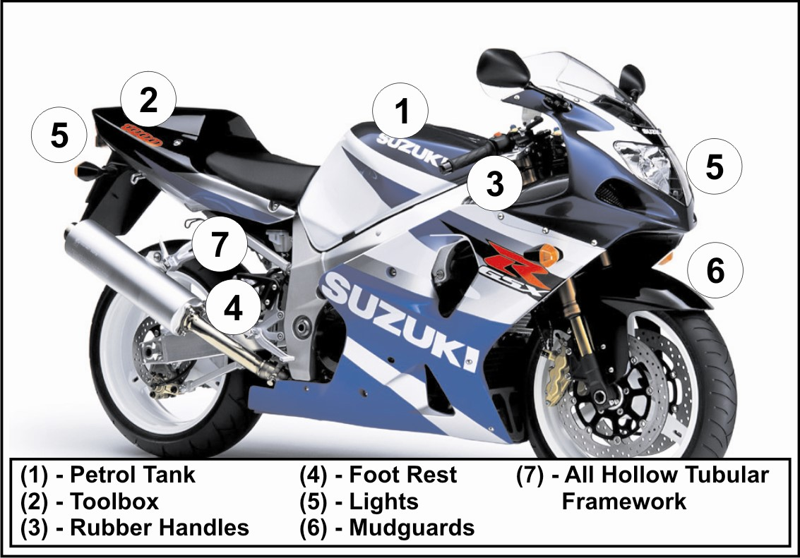
1.
2.
3.
4.
5.
6.
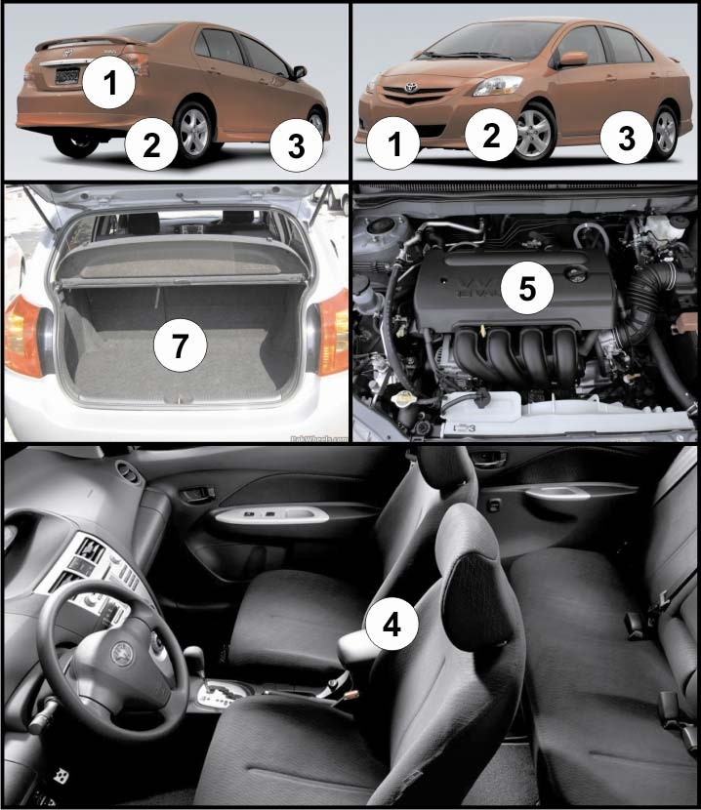
1.
2.
3.
4.
5.
6.
7.
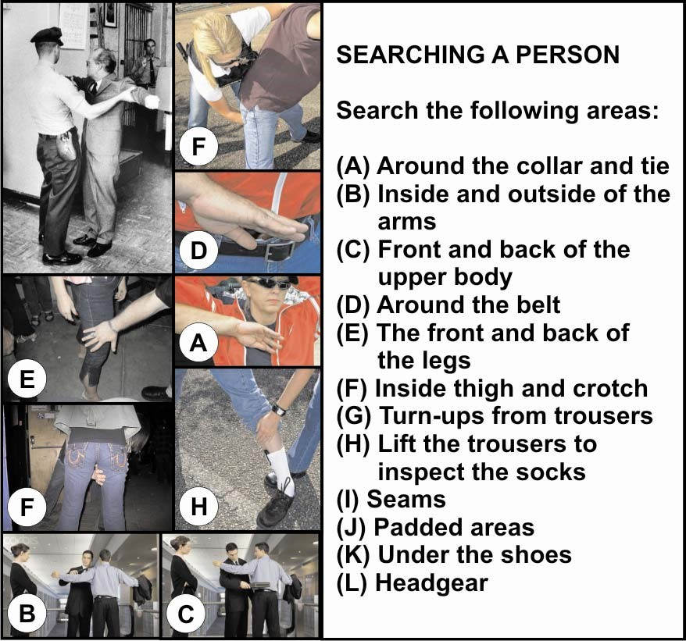
A.
B.
C.
D.
E.
F.
G.
H.

LEARNER ACTIVITY 2 (page 94)

When searching a vehicle, person or a briefcase a security officer needs to know what he is looking for. List those critical factors that a security officer always needs to lookout for.
What to look for:

♦ Hand guns
♦ | Ammunition
♦ | Parts of weapons
♦ | Knives
♦ | Detonators
♦ | Components of bombs
♦ | Miniature cameras
♦ | Stolen/pilferage items
 | Requirements achieved | YES |  | NO
Comments in support of decision
_______________________________________________________________________
_______________________________________________________________________
_______________________________________________________________________
_______________________________________________________________________
_______________________________________________________________________
_______________________________________________________________________
_______________________________________________________________________

LEARNER ACTIVITY 3 (page 94)

When the search is completed, the person should be requested to produce his or her identity document or any official document in his or her possession. The identity documents should be checked carefully and compared with the person by means of the following guidelines, Photograph, stamps and condition of the document. Explain how these should be checked.
♦ Photograph: Carefully compare the photograph with the person. Take into consideration that the photo was probably taken a while ago which would mean a difference in age and hairstyle. The person can be requested to remove their headgear if it is obstructing a positive identification.

♦ Stamps: The stamp on the document should be confirmed to be genuine. Make sure that where the stamp crosses the corner of the photo it is even. If not it could mean that the original photo has been removed and substituted with another.

♦ Condition of document: The condition of the document should be checked against the date of issue. One should become suspicious if the condition does not correspond with the age of the document.
_______________________________________________________________________
_______________________________________________________________________
_______________________________________________________________________
_______________________________________________________________________
_______________________________________________________________________
_______________________________________________________________________
_______________________________________________________________________
_______________________________________________________________________
Requirements achieved | YES |  | NO
Comments in support of decision
_______________________________________________________________________
_______________________________________________________________________
_______________________________________________________________________
_______________________________________________________________________
_______________________________________________________________________
_______________________________________________________________________
_______________________________________________________________________

LEARNER ACTIVITY 4 (page 95)

What should be the two main characteristics of the questions asked of the person being searched?
Question should be specific and direct such as:

♦ What is your name?
♦ | What is your age?
♦ | Where do you live? Etc.
 | Requirements achieved | YES |  | NO
Comments in support of decision
_______________________________________________________________________
_______________________________________________________________________
_______________________________________________________________________
_______________________________________________________________________
_______________________________________________________________________
_______________________________________________________________________
_______________________________________________________________________

LEARNER ACTIVITY 5 (page 95)

What are the general rules when you search someone?
♦ | When you search someone, keep in mind the legal limitations laid down by the Criminal Procedure Act.
♦ | Search the person systematically and thoroughly.
♦ | Try to determine where this person could hide an article on his person or in his clothing.
♦ | At all time be alert for a possible attack when searching the person.
♦ | If contraband such as drugs, stolen or smuggled goods are found, be careful when seizing it that the suspect cannot say that the security officer planted the item in his luggage or in his clothing.
♦ | Identify the person by means of legal ID or driver’s license.
 | Requirements achieved | YES |  | NO
Comments in support of decision
_______________________________________________________________________
_______________________________________________________________________
_______________________________________________________________________
_______________________________________________________________________
_______________________________________________________________________
_______________________________________________________________________
_______________________________________________________________________

LEARNER ACTIVITY 6 (page 95)

When searching employees during egress control, there is a certain procedure to follow - (this can be adapted depending on the site). List all of them.
It is not feasible to search every employee when they’re all on their way home. Therefore the following procedure can be adapted to suit your circumstances:

♦ Select a person to be searched.
♦ First get their permission to be searched.
♦ They should then be escorted to the search room.
♦ Always make sure that there is a witness present.
♦ Ask the person if they have any company property to declare - if yes, ask them to produce it.
♦ If the search is negative, thank them for their co-operation and allow them to leave. ♦ If the search is positive follow the procedure for detaining and arrest.
Requirements achieved | YES |  | NO
Comments in support of decision
_______________________________________________________________________
_______________________________________________________________________
_______________________________________________________________________
_______________________________________________________________________
_______________________________________________________________________
_______________________________________________________________________
_______________________________________________________________________

LEARNER ACTIVITY 7 (page 96)

What do you have to keep in mind when searching a vehicle?
♦ | First determine that the vehicle is allowed to enter or exit the site.
♦ | Always keep in mind that searching a vehicle thoroughly takes time so it is usually done quite superficially.
♦ | A vehicle has many hiding places. Being systematic and thorough will help you to find possible hidden items. As you become experienced in this task you will discover many hiding places and you will also develop a sense of where to look.
♦ | lieve there is a good reason to do so. |  | Taking the time to search a vehicle thoroughly can only be justified when you be-
 | Requirements achieved | YES |  | NO
Comments in support of decision
_______________________________________________________________________
_______________________________________________________________________
_______________________________________________________________________
_______________________________________________________________________
_______________________________________________________________________
_______________________________________________________________________
_______________________________________________________________________

LEARNER ACTIVITY 8 (page 96)

Study the image below and explain procedure to follow when searching a vehicle. Base your explanation of the procedures on the scenario below (image)
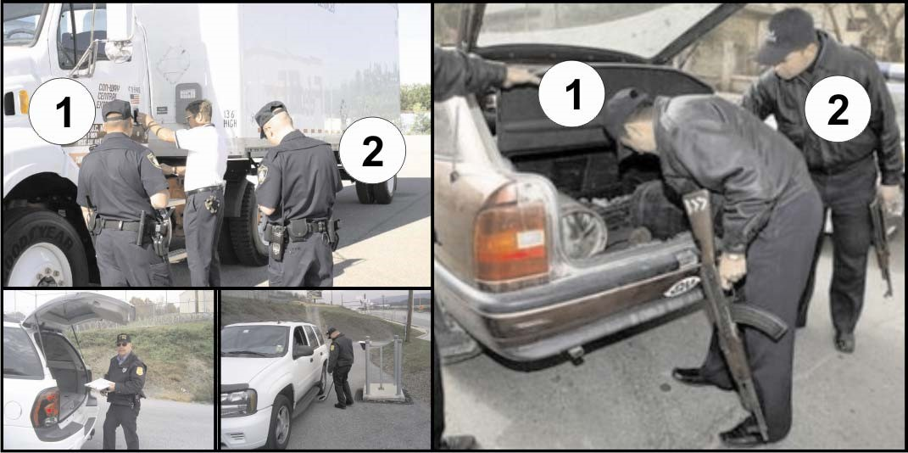
♦ Firstly inform the people in the vehicle that they and the vehicle are liable to be searched.
♦ They should then be told to get out of the vehicle.
♦ One security officer must conduct the actual search while a second security officer stands back to supervise and observe.
♦ If nay contraband or illegal items are found during the search, the observing security officer should record it in his or her pocket book all the details, such as the type of item, number of items, where found, and the reactions of the persons (suspects).
♦ If the person refuses to allow the search procedure, they will be denied access to the premises. _______________________________________________________________________
_______________________________________________________________________
_______________________________________________________________________
_______________________________________________________________________
_______________________________________________________________________
_______________________________________________________________________
_______________________________________________________________________
_______________________________________________________________________
_______________________________________________________________________
_______________________________________________________________________

Requirements achieved | YES |  | NO
Comments in support of decision
_______________________________________________________________________
_______________________________________________________________________
_______________________________________________________________________
_______________________________________________________________________
_______________________________________________________________________
_______________________________________________________________________ SELF-ASSESSMENT

The learner must make use of the following self-evaluation checklist to rate himself against the learning outcomes of this particular training module in establishing the level of mastery of the information.

- Not able to comply

- Reasonable compliance (Not acceptable for final evaluation)

- Able to comply fully
 | LEARNING OUTCOMES | 1 | 2 | 3
1 | Search people, vehicles and goods making use of relevant methods and equipment.
2 | Explain the procedures of handing over of unauthorized people, vehicles or goods.
3 | Complete and verify all relevant documentation of an incident.

_____________________________________ ________________________ Evidence Collector Signature Date

_____________________________________ ________________________
Security Officer Signature Date

LEARNING UNIT 5

Escorting

LEARNING OUTCOMES

A learning credited with this unit will be able to:

- Identify the threat before undertaking an escort.
- Name the resource requirements during escorting.
- List the different security tasks during escorting.
- Explain the actions for planning and preparing for escorting.
- List the criteria when planning a route map and explain the steps when planning a route map.
- Explain contingency plans for valuables, persons or suspects.
- Identify all valuables/persons or suspects to be escorted.
- Determine classification / recent behaviour of valuables / persons or suspects and identify special needs when preparing for escort assignments.
- Perform suspect search when required according to relevant legislation.

LEARNER ACTIVITY 1 (page 107)

You have to escort a suspect from the control room to a police station and you have to do a threat assessment. You will need certain knowledge with regard to the threat before you can do the threat assessment. What would that be?

A security officer will need the following knowledge to assess, and therefore be prepared for counteracting any threat:

♦ A contingency plan (including an evacuation plan).
♦ The company standing operational procedure.
♦ Written site specific and post instructions.
♦ Command structure (especially after hours).
♦ Backup and support systems.
♦ Knowledge of the environment in which the site is located.
♦ Knowledge of the type of business conducted at the site.
♦ Knowledge of the history of crime at the premises.
♦ A comprehensive terrain analysis, which would be conducted by the officer to ascertain the mapping of the terrain including location of buildings, shops, gates, parking venues, loading bays, etc.
Requirements achieved | YES |  | NO
Comments in support of decision
_______________________________________________________________________
_______________________________________________________________________
_______________________________________________________________________
_______________________________________________________________________
_______________________________________________________________________
_______________________________________________________________________
_______________________________________________________________________

LEARNER ACTIVITY 2 (page 108)

You have received an operational instruction to escort valuables from the control room of your company to the human resource department. The valuables will arrive at the control room on Tuesday, 12 July 2006 at 09:00. You have to escort the valuables from the control room to Mr Strydom. Before you can undertake the escort, you have to do a complete threat assessment. Discuss the steps that you will follow when doing a threat assessment. (Guidelines for progression of the threat assessment)
The security officer has to follow these steps during his or her threat assessment before they can start with their escort duty:

♦ Step 1: Identify the potential threats.
♦ |  | Step 2: | Assess the identified threats.
♦ |  | Step 3: | Give priority to the threat in relation to the risk.
♦ |  | Step 4: | Evaluate the valuable, person or suspect to determine if there are
 |  |  | any specific details that should be included in the plan.
♦ |  | Step 5: | Evaluate the route and destination to be followed during escorting
♦ |  | Step 6: | Make recommendations to reduce the risks.
♦ |  | Step 7: | Apply additional security measures.
♦ |  | Step 8: | Implement new security measures.
 | Requirements achieved |  |  | YES |  | NO
 | Comments in support of decision
_______________________________________________________________________
_______________________________________________________________________
_______________________________________________________________________
_______________________________________________________________________
_______________________________________________________________________

LEARNER ACTIVITY 3 (page 108)

You have received an operation instruction and you have to escort a truck with mine debris or waste. The threat has already been identify that suspects might “hijack” the truck. Evaluate the identified threat. You are also allowed to use site-related examples.
When evaluating the identified threats, the security officer needs to analyse the following factors:

♦ Who, what, where, when and how will the threat be applied against the valuables, person or suspect.
♦ Verify personnel information of valuables, persons or suspects:
⇒ Who is the person or suspect?
⇒ What type of valuables?
⇒ Classify the threat level.
⇒ Classify the valuables, persons or suspects.
⇒ History of valuables, person or suspect.
♦ Particulars of the threat:
⇒ Who is posing a threat to the escorted items?
⇒ Where is it likely to happen?
⇒ What can be done to prevent it?
⇒ Are the security measures adequate to deal with various contingencies?
♦ Own manpower:
⇒ The officer must determine how many of his own department will be needed to conduct the escort.
⇒ What measures have been taken to prevent an attack on the valuables person or suspect?
⇒ How the threat and the risk is going to be managed?
Requirements achieved | YES |  | NO
Comments in support of decision
_______________________________________________________________________
_______________________________________________________________________
_______________________________________________________________________
_______________________________________________________________________
_______________________________________________________________________
_______________________________________________________________________

LEARNER ACTIVITY 4 (page 109)

There are three different types of escorting. Name the different types of escorting and give examples in your answer (you are allowed to give site related examples).
Valuables or goods. In some instances the security officer will not be responsible for the valuables or goods themselves, but for the person who is carrying them.

Valuables or goods can include the following:

♦ Documents
♦ Previous stones
♦ Jewellery
♦ Trophies
♦ Bullion
♦ Cash
♦ Electronic equipment
♦ Firearms
♦ Artwork
♦ Mining debris (rubble) etc

Suspects.

A suspect may be someone who is in a restricted area and has to be escorted out of the building. Or a suspect could be a person who has been caught in a criminal act and needs to be escorted to a place of safe keeping where he will be handed over to the police.

Persons or visitors. For example, a visitor who needs to be escorted from the reception security area at the entrance of the premises to a specific location such as a boardroom or some other meeting place.

It is also sometimes expected that the security officer does static guard duty at a meeting room and then escort the visitor back to his vehicle.

A visitor could be a person who is visiting one of the staff members of the company on official business and has to be escorted by a security officer to the staff member’s office.

The following are typical visitors that a security officer will encounter daily:

♦ Someone delivering a package
♦ A person attending a meeting
♦ A person who has been summoned by another
♦ Contractors rendering maintenance service
♦ Telecommunication services
♦ City council officials
♦ Occupational health and safety inspectors

Requirements achieved | YES |  | NO
Comments in support of decision
_______________________________________________________________________
_______________________________________________________________________
_______________________________________________________________________
_______________________________________________________________________
_______________________________________________________________________
_______________________________________________________________________
_______________________________________________________________________

LEARNER ACTIVITY 5 (page 111)

Escorting can take place on foot or by vehicle. Explain when you would do an escort on foot and when you would do an escort with a vehicle.
♦ | Food escort, which may include visitors, goods, suspects, etc.
♦ | Vehicle escort, which may be for visitors vehicles, transport vehicles, etc.
 | Requirements achieved | YES |  | NO
Comments in support of decision
_______________________________________________________________________
_______________________________________________________________________
_______________________________________________________________________
_______________________________________________________________________
_______________________________________________________________________
_______________________________________________________________________
_______________________________________________________________________

LEARNER ACTIVITY 6 (page 112)
Complete the following table with regard to determining the special needs or requirements for escort. Fill in the missing information.

♦ Category 1:
♦ Suspects:
♦ Category 3:

How should the goods be handled, packed, transported and delivered?
♦ Category 1: Escorting of vehicles will need two (2) security officers and one (1) vehicle.
♦ Category 2: Escorting of suspects will need two (2) security officers.
♦ Category 3: Escorting of persons or visitors will need one (1) security officer.
Requirements achieved | YES |  | NO
Comments in support of decision
_______________________________________________________________________
_______________________________________________________________________
_______________________________________________________________________
_______________________________________________________________________
_______________________________________________________________________ SELF-ASSESSMENT

The learner must make use of the following self-evaluation checklist to rate himself against the learning outcomes of this particular training module in establishing the level of mastery of the information.

- Not able to comply

- Reasonable compliance (Not acceptable for final evaluation)

- Able to comply fully
 | LEARNING OUTCOMES | 1 | 2 | 3
1 | Identify the threat before undertaking an escort.
2 | Name the resource requirements during escorting.
3 | List the different security tasks during escorting.
4 | Explain the actions for planning and preparing for escorting.
5 | List the criteria when planning a route map and explain the steps when planning a route map.
6 | Explain contingency plans for valuables, persons or suspects.
7 | Identify all valuables/persons or suspects to be escorted.
8 | Determine classification / recent behaviour of valuables / persons or suspects and identify special needs when preparing for escort assignments.
9 | Perform suspect search when required according to relevant legislation.

_____________________________________ ________________________ Evidence Collector Signature Date

_____________________________________ ________________________
Security Officer Signature Date

